IFG Explore Cooking with Eggs
3rd Year
2nd Term, Week Five Interest

Aim: Cooking with eggs.

Objectives:
To cook one or two of the following
Scotch eggs
French toast
Bread and butter pudding

Equipment:
As required depending on your choice of recipe.

Pre SetUp:
Organise some games for when the girls start to arrive
Set tables up and put out equipment

Set Up:
Usual set up and roll call.

Games:
Sardines:
This game is a variation of hide and seek, it is best played outdoors.
One player is “it” and she goes off to hide while the other players count to 100 by 2’s or 5’s. When the other players have finished counting, they call out “coming ready or not”, everyone then goes off to find “it”, all looking separately. As each girl finds “it” she hides in the same space until finally all the players are in the same hiding place. The first player to find “it” becomes “it” for the next game.

Devotions:
Jesus is the Bread of Life:
Matthew 6:11 is a prayer to, “Give us today our daily bread.” What does that mean? (We are asking for God to provide for our needs day by day.) Do we always see God as our Provider? How has God provided for our family? Think of specific instances throughout the year where God has been faithful.
In John 6: 35, Jesus says, “I am the bread of life. He who comes to me will never go hungry, and he who believes in me will never be thirsty.” Why do we eat bread (or food, for that matter?) (To make us full; to keep us physically alive.) Why does Jesus call Himself bread? (He is what we need for our spiritual life.) How can we “never go hungry” if we have Christ? (He satisfies spiritual needs while food satisfies our physical needs.) If we eat everyday to keep us alive physically, what should we do to keep us alive spiritually? (Spend time with God daily.)

Teaching Session:
Scotch eggs:
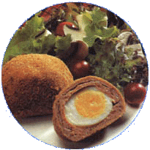
Preparation Time: 15 minutes
Cooking Time: 7 minutes each Scotch Egg
Ingredients:
Enough eggs so girls can each have ½ a scotch egg
Enough sausage meat to cover the eggs
Eggs for dipping (see below)
Dry breadcrumbs
Oil for cooking
How to make:
Hard boil the eggs
Wrap the sausage meat around each egg
Beat eggs then dip each Scotch egg into the beaten eggs then breadcrumbs
Put enough oil in fry pan and cook, turning frequently to ensure even cooking.
Note: If you make the Scotch eggs consider freezing these and using them as part of the menu for the Awardz night on last night of term.

French toast:
Prep time: 10 min
Cook time: 5 min
Ingredients:
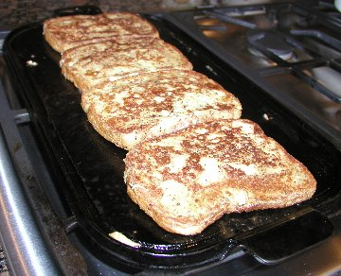
4 eggs
4 tablespoons milk
Several drops pure vanilla extract
1/4 teaspoon ground cinnamon
4 slices bread, with crusts*
Butter for cooking
Icing sugar
Maple syrup, honey, and/or jam (for topping)

* Coaches Tip: You can use breads with multi-grains, raisins, and/or nuts in them. It makes the French toast more nutritional and very tasty. Fresh bread will absorb batter quicker than stale bread. In other words, you can use any type of bread you choose.
Preparation:
In 33- x 23 cm (approx) baking pan or dish, combine the eggs, milk, vanilla extract, and cinnamon; beat with a fork until well mixed. Layer the bread slices into the egg mixture and let soak about 5 minutes or until most of egg mixture is absorbed, turning once.
On a heavy skillet with a generous amount of hot melted butter, place prepared bread in a single layer and cook until the bread is golden brown and crusted on the bottom, about 2 minutes. Turn and cook until the second side is golden, about 1 to 1 ½ minutes.
Place on individual serving plates, and sprinkle each slice of French toast with icing sugar. Serve hot with maple syrup, honey, sugar, and/or jam.

Note: If making a large batch of French toast, preheat the oven to 100 degrees Celsius. Transfer the French toast from the skillet to a baking sheet. Cover lightly with aluminium foil and place in the oven to keep warm while you cook the other slices.
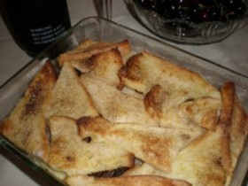
Bread and Butter pudding:
8 slices of bread, buttered
½ cup sultanas
3 level tablespoons caster sugar
Ground cinnamon
1 ½ cups skimmed milk
4 eggs
1 tsp vanilla essence
Method:
Heat oven to 160 degrees Celsius.
Cut each slice of bread and butter into 4 triangles. Place 1/3 of the bread in the case of a lightly greased baking dish. Sprinkle with half the sultanas, one tablespoon of caster sugar and a shake or two of cinnamon. Place half of the remaining bread on top and then the remaining sultanas plus one tablespoon sugar and another shake or two of cinnamon. Place the remaining bread and butter on the top, trying to ensure all the sultanas are covered by the bread. Sprinkle the final tablespoon of caster sugar over the top.

In a separate bowl beat the eggs and skimmed milk together. Carefully pour over the bread and fruit mix. Sprinkle on a little more cinnamon.

Let stand for half an hour. Don’t worry if the top pieces of bread are not submerged under the milk – these are going to be the nice crispy bits.

Bake at 160 degrees Celsius until the “custard” has set and the pudding is golden brown on the top. This will take about 40 minutes.

Coaches tip: If you can, totally cover the sultanas with the bread purely to protect them from over-cooking and going hard.

Closing Prayer

Home time & notices:

